PRACTICE PROGRAM – 29/07/2024

1. write a java program to create the class hirerachy for a employee of company. The base class should be employee with subclasses manager,developer and programmer. Each subclass should have the properties such as name,address,salary and jobtitle. Implement method for calculating bonus and generate the performance report.

Program:

class Employee {

protected String name;

protected String address;

protected double salary;

protected String jobTitle;

public Employee(String name, String address, double salary, String jobTitle) {

this.name = name;

this.address = address;

this.salary = salary;

this.jobTitle = jobTitle;

}

public double calculateBonus() {

return salary \* 0.1;

}

public void generatePerformanceReport() {

System.out.println("Employee Name: " + name);

System.out.println("Job Title: " + jobTitle);

System.out.println("Salary: " + salary);

}

}

class Manager extends Employee {

private String department;

public Manager(String name, String address, double salary, String jobTitle, String department) {

super(name, address, salary, jobTitle);

this.department = department;

}

@Override

public double calculateBonus() {

return super.calculateBonus() \* 1.5;

}

@Override

public void generatePerformanceReport() {

super.generatePerformanceReport();

System.out.println("Department: " + department);

}

}

class Developer extends Employee {

private String programmingLanguage;

public Developer(String name, String address, double salary, String jobTitle, String programmingLanguage) {

super(name, address, salary, jobTitle);

this.programmingLanguage = programmingLanguage;

}

@Override

public void generatePerformanceReport() {

super.generatePerformanceReport();

System.out.println("Programming Language: " + programmingLanguage);

}

}

class Programmer extends Developer {

public Programmer(String name, String address, double salary, String jobTitle, String programmingLanguage) {

super(name, address, salary, jobTitle, programmingLanguage);

}

@Override

public double calculateBonus() {

return super.calculateBonus() \* 1.2;

}

}

public class Main {

public static void main(String[] args) {

Manager manager = new Manager("John Doe", "123 Main St", 100000, "Manager", "IT");

manager.generatePerformanceReport();

System.out.println("Bonus: " + manager.calculateBonus());

Developer developer = new Developer("Jane Smith", "456 Elm St", 80000, "Developer", "Java");

developer.generatePerformanceReport();

System.out.println("Bonus: " + developer.calculateBonus());

Programmer programmer = new Programmer("Bob Johnson", "789 Oak St", 70000, "Programmer", "Python");

programmer.generatePerformanceReport();

System.out.println("Bonus: " + programmer.calculateBonus());

}

}

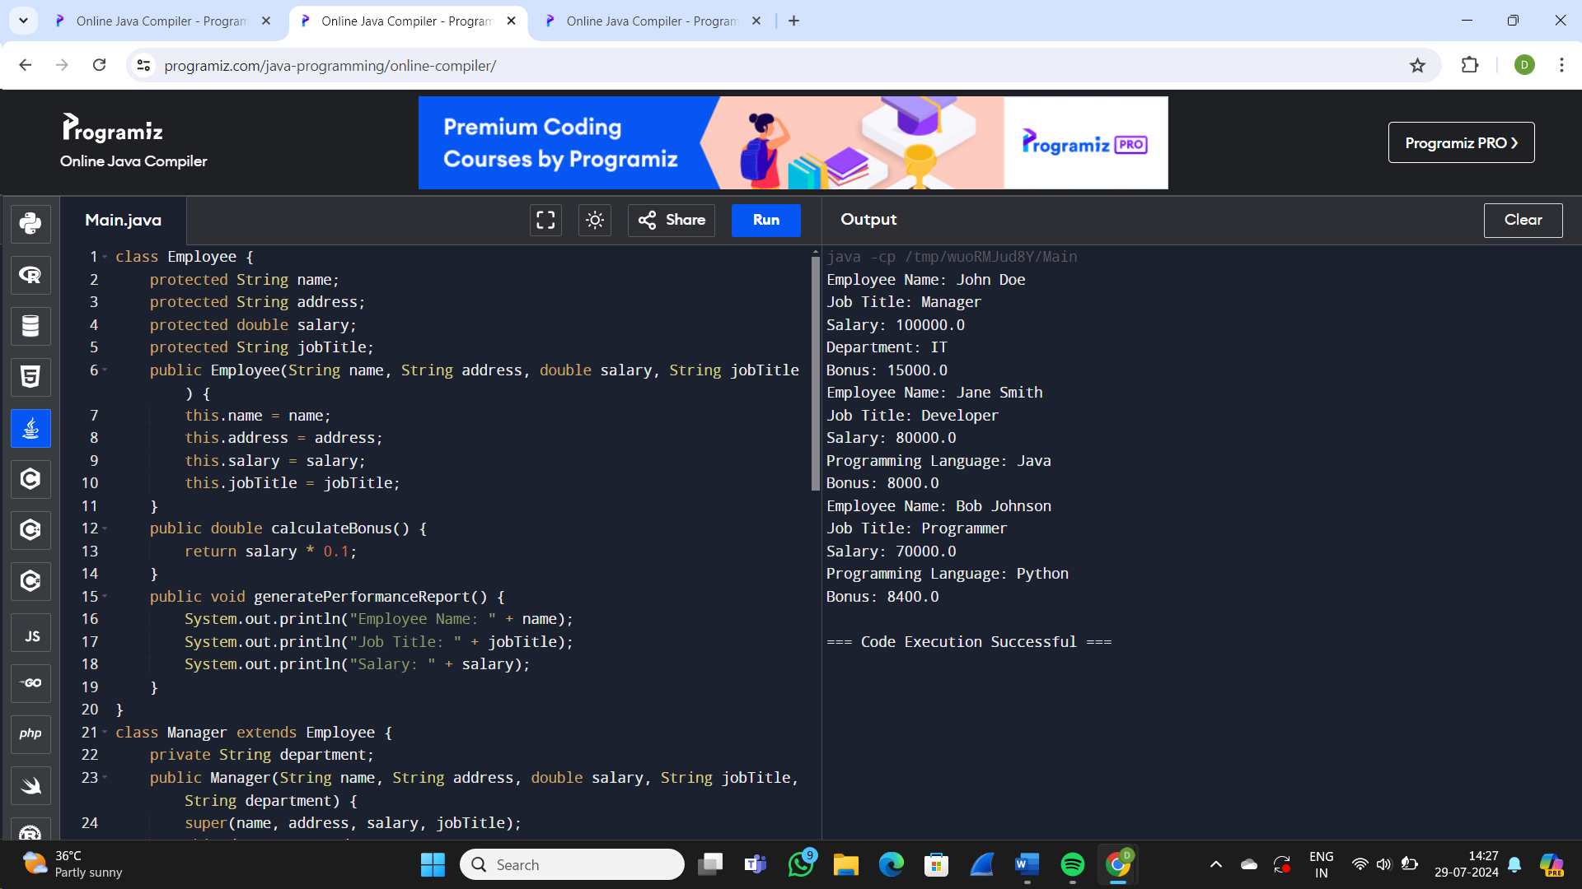

1. Write a java program that takes an integer if it is an even number print that number with exception handling.

Program:

public class Main {

public static void checkEven(int number) throws Exception {

if (number % 2 != 0) {

throw new Exception("The number is odd: " + number);

} else {

System.out.println("The number is even: " + number);

}

}

public static void main(String[] args) {

try {

checkEven(3); // Change this number to test with different values

} catch (Exception e) {

System.err.println(e.getMessage());

       }

    }

}

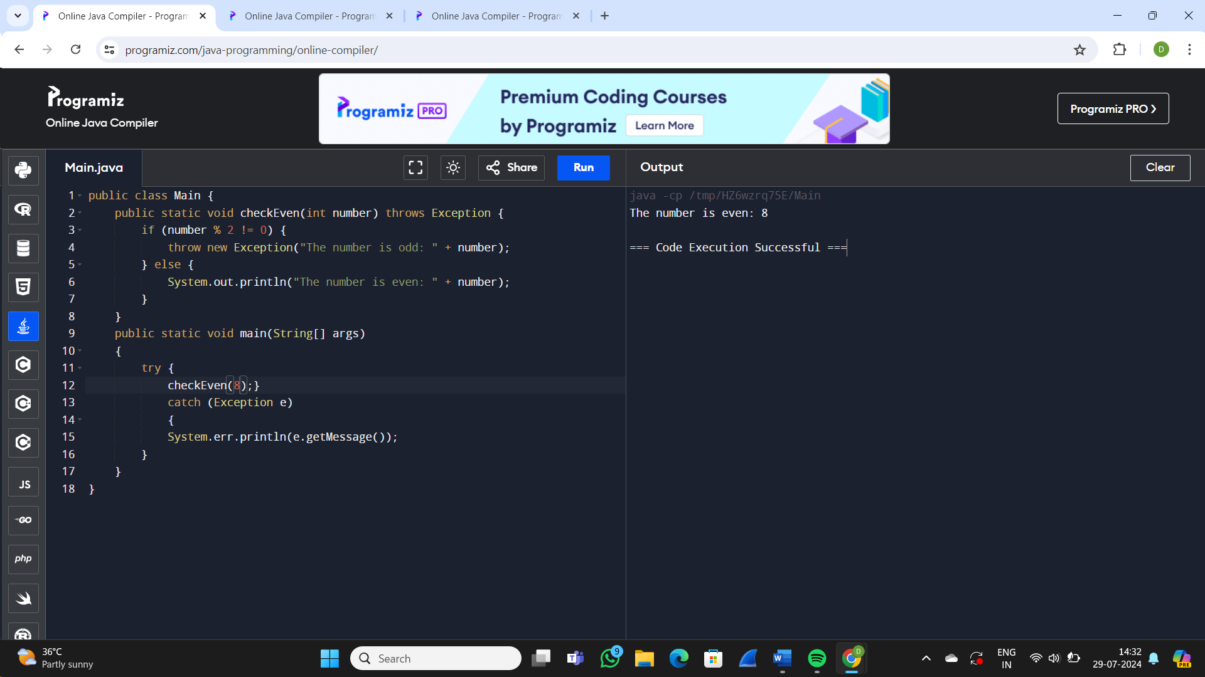

1. Write a java program to create method that take string as input that string doesn’t contain vowels if all contains vowels prove the exception

Program:

public class VowelChecker

{

public static void checkVowels(String input) throws VowelException

{

String vowels = "aeiouAEIOU";

for (char c : input.toCharArray())

{

if (vowels.indexOf(c)!= -1)

{

throw new VowelException("The string contains vowels");

}

}

System.out.println("The string does not contain vowels: " + input);

}

public static class VowelException extends Exception

{

public VowelException(String message)

{

super(message);

}

}

public static void main(String[] args)

{

try

{

checkVowels("bcd");

checkVowels("hello");

}

catch (VowelException e)

{

System.out.println(e.getMessage());

}

}

}

